Summary
In this chapter, we began our journey into Machine Learning by understanding its fundamental idea: enabling machines to learn from data rather than being explicitly programmed for every possible scenario. We explored how machine learning represents a specialized subset of Artificial Intelligence and how Deep Learning further extends these capabilities through multi-layered neural networks.
We compared how humans learn from experience with how machines learn from data. Just as humans recall past experiences, derive insights, and apply learned rules to new situations, machine learning systems analyze historical data, identify patterns, and generate predictions for unseen data.
The chapter also examined the relationship between Artificial Intelligence, Machine Learning, and Deep Learning, clarifying how these fields are interconnected yet distinct in scope and methodology.
We discussed a wide range of real-world applications across industries such as business intelligence, customer relationship management, security, human resources, supply chain management, natural language processing, autonomous vehicles, weather forecasting, recommendation systems, and generative AI. These examples demonstrate how deeply embedded machine learning is in modern society.
In addition, we introduced essential machine learning terminology including models, algorithms, features, datasets, supervised and unsupervised learning, reinforcement learning, overfitting, underfitting, training and test data, accuracy, loss functions, and hyperparameters. Understanding these foundational concepts is critical before progressing to algorithm design and implementation.
Finally, we outlined what you will gain from this book — a strong conceptual foundation, hands-on Python implementation skills, practical exposure to regression and classification models, and the ability to evaluate machine learning systems using appropriate performance metrics.
This chapter establishes the conceptual framework required to understand and implement machine learning algorithms in the chapters that follow.

Chapter-End Exercises
Conceptual Questions
- Explain in your own words how Machine Learning differs from traditional rule-based programming.
- Describe the relationship between Artificial Intelligence, Machine Learning, and Deep Learning.
- Compare how humans learn from experience with how machines learn from data.
- Define the following terms:
  - Model
  - Algorithm
  - Feature
  - Dataset
  - Hyperparameter
- What is the difference between overfitting and underfitting? Why are they problematic?

Short Analytical Exercises
- Identify whether the following problems are best solved using supervised, unsupervised, or reinforcement learning. Justify your answer.
  - Email spam detection
  - Customer segmentation
  - Self-driving car navigation
  - Product recommendation system
- Consider a weather prediction system.
  - What would be the features?
  - What would be the label (if supervised learning is used)?
- Suppose a model performs very well on training data but poorly on new test data.
  - What is this problem called?
  - Suggest two possible ways to reduce this issue.

Reflection Exercise
- List three applications of machine learning that you interact with daily. Briefly explain how data might be used in each case.

Conceptual Diagram 1: AI → ML → DL Hierarchy

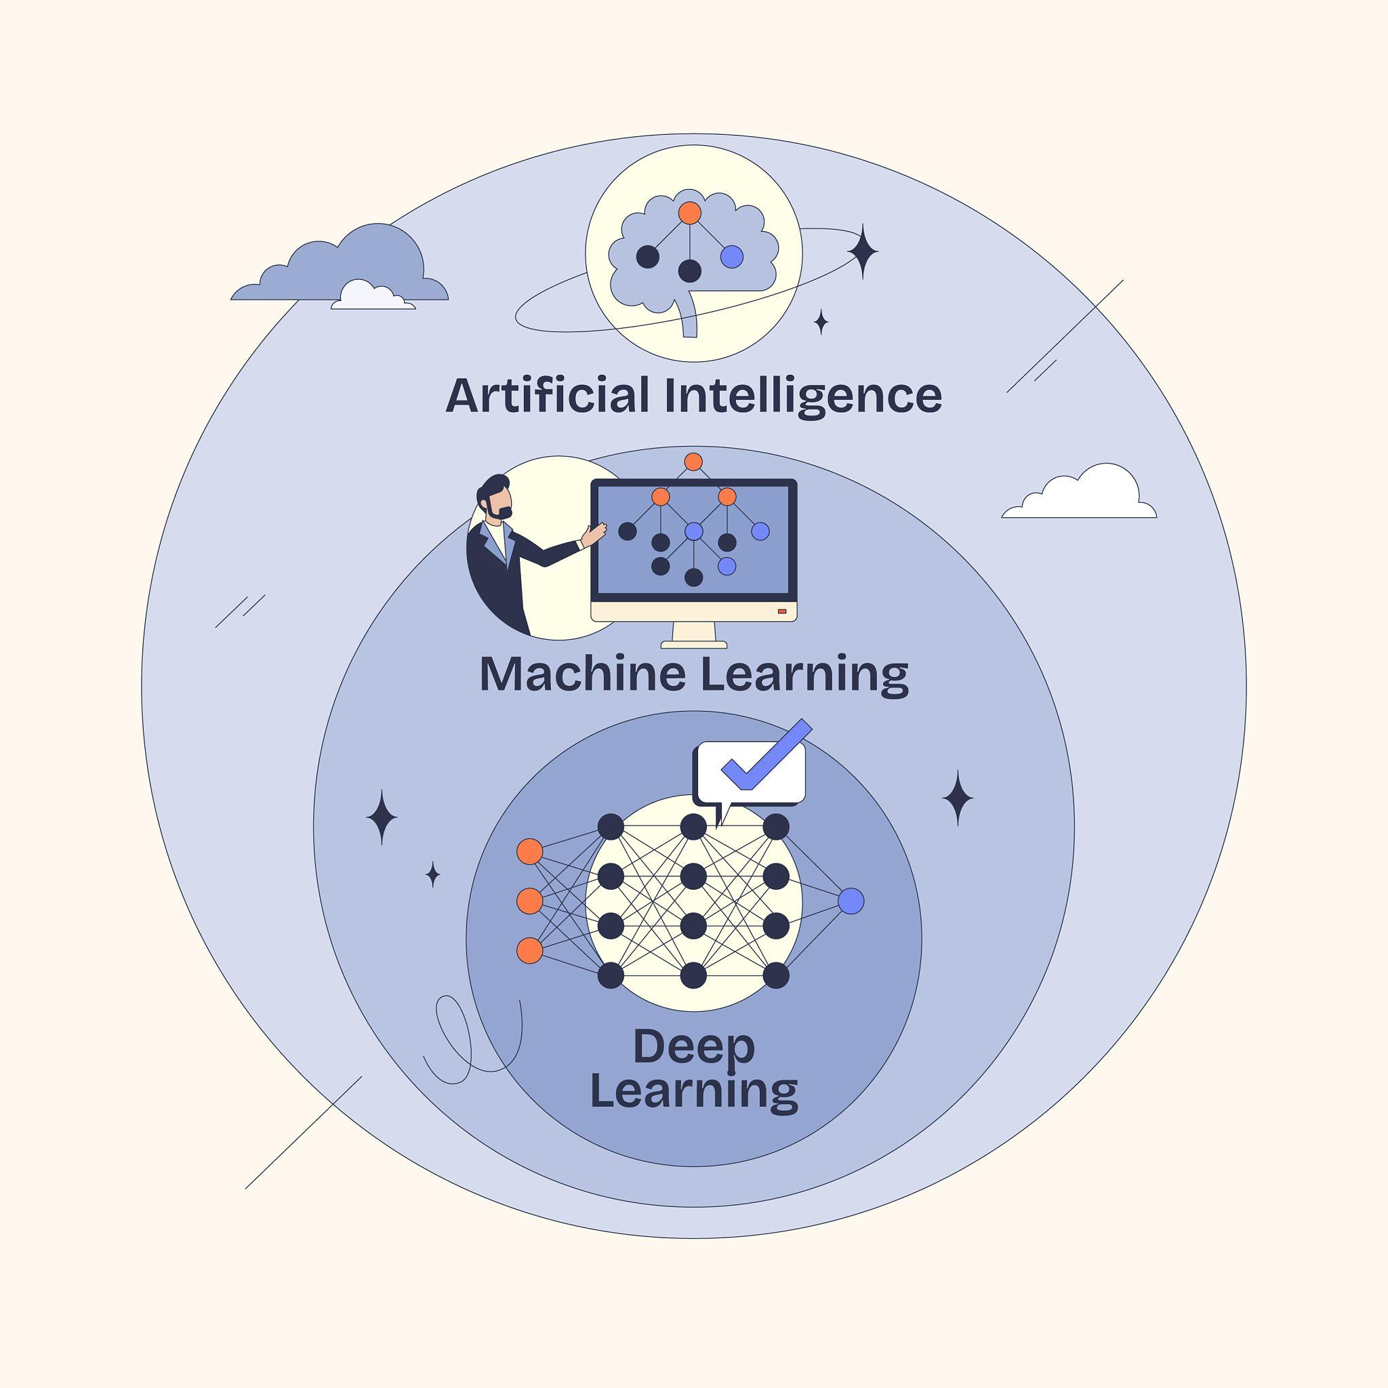
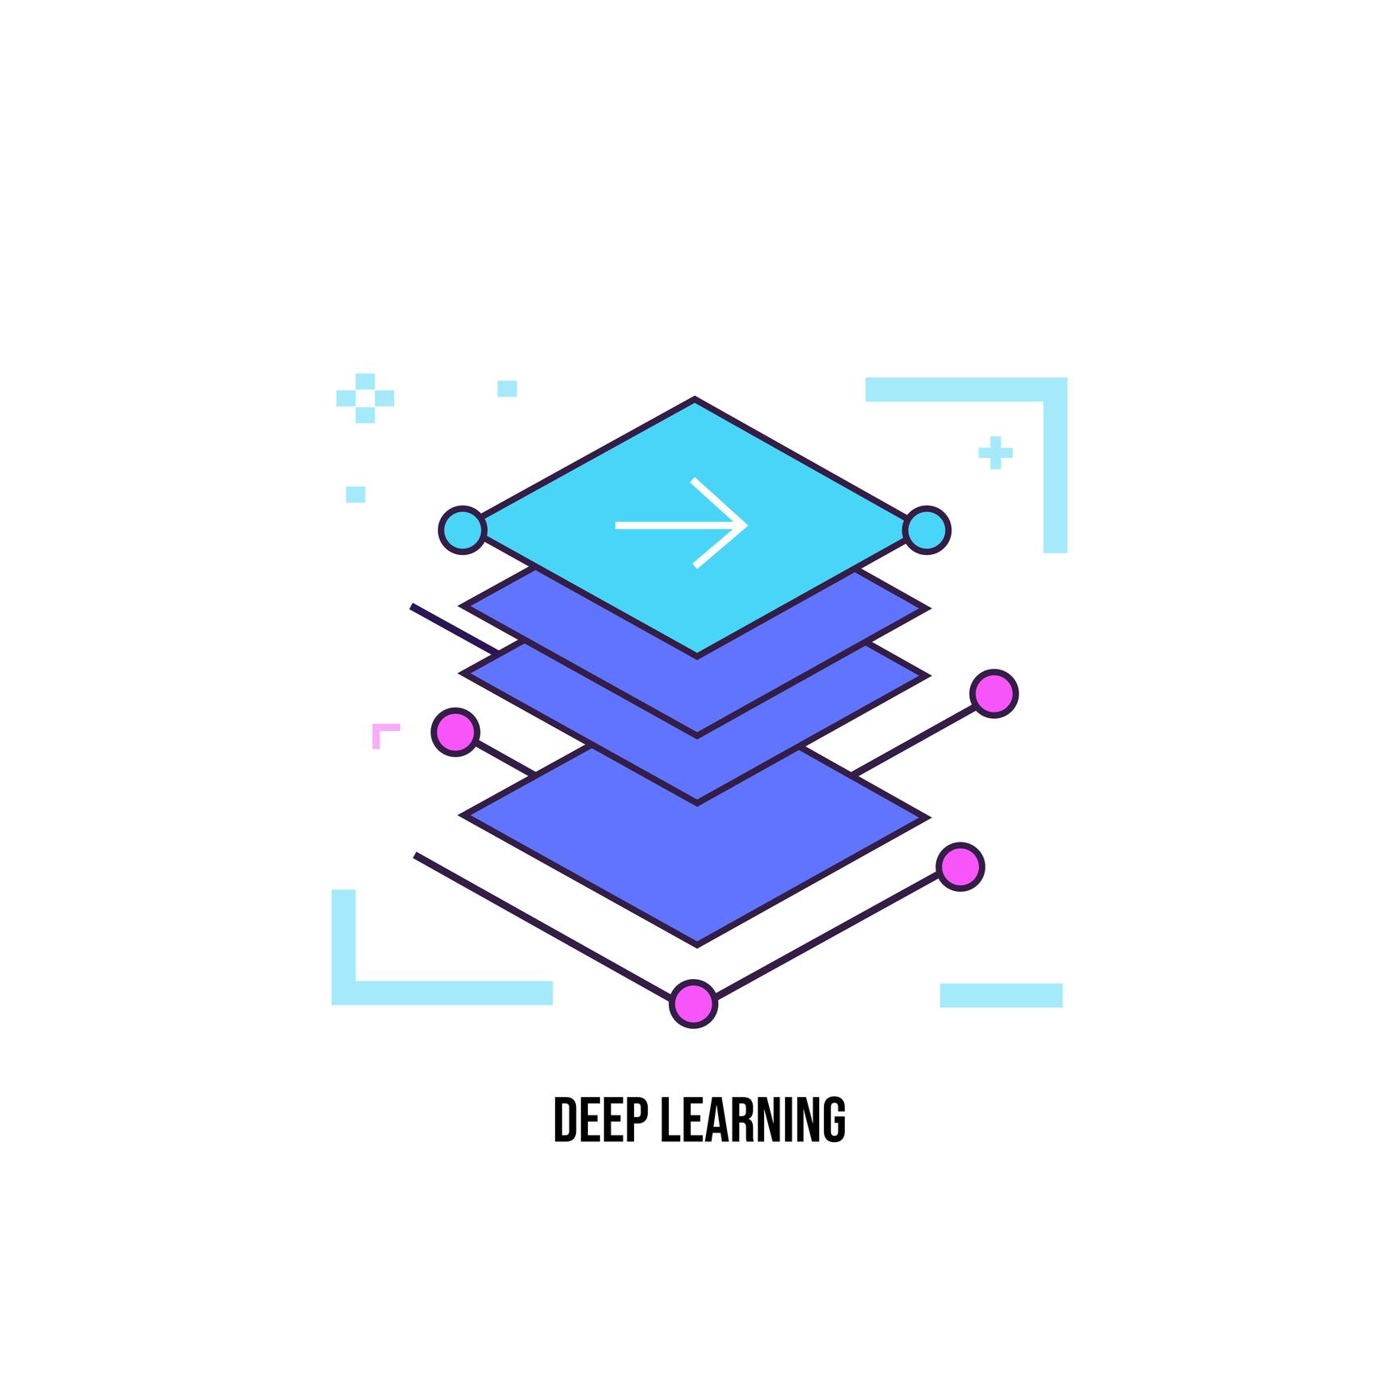
Explanation (For Textbook Use)
- Artificial Intelligence (AI) – The broadest field focused on building systems capable of performing tasks that require human-like intelligence such as reasoning, perception, and decision-making.
- Machine Learning (ML) – A subset of AI that enables systems to learn from data and improve performance without explicit programming.
- Deep Learning (DL) – A specialized subfield of ML that uses multi-layered neural networks to model complex patterns in large datasets.
You may caption this as:
Figure 1: Relationship between Artificial Intelligence, Machine Learning, and Deep Learning

Conceptual Diagram 2: Humans vs Machines Learning
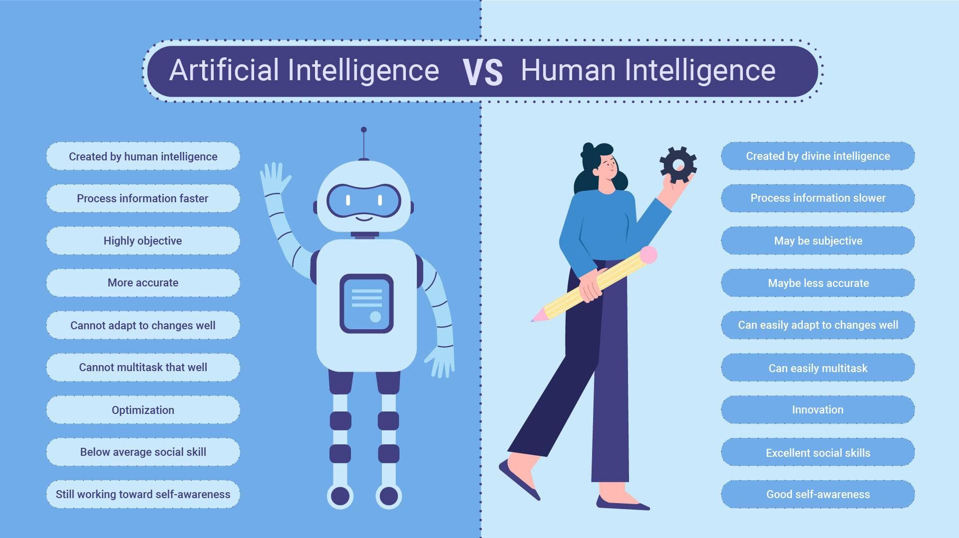
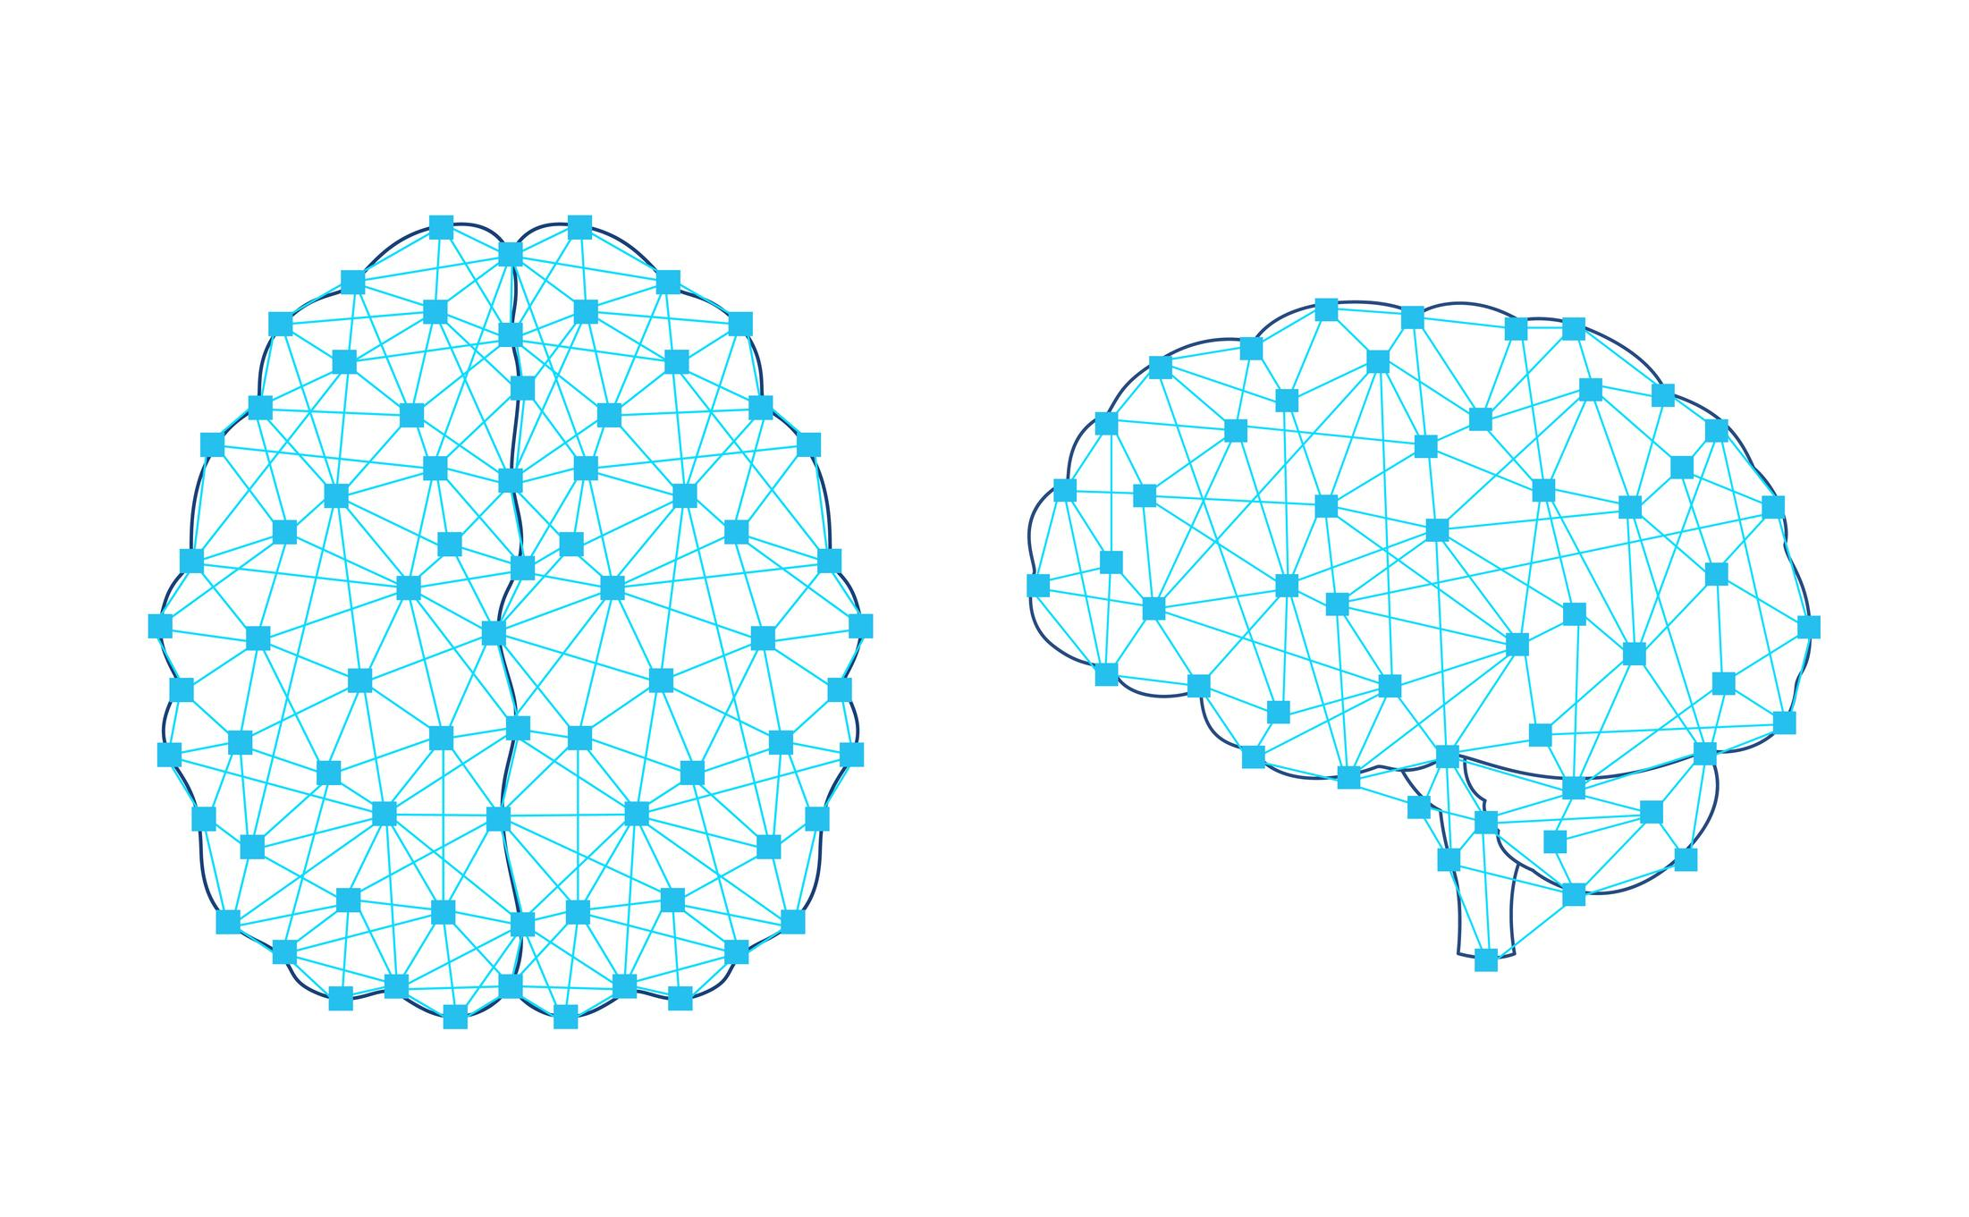

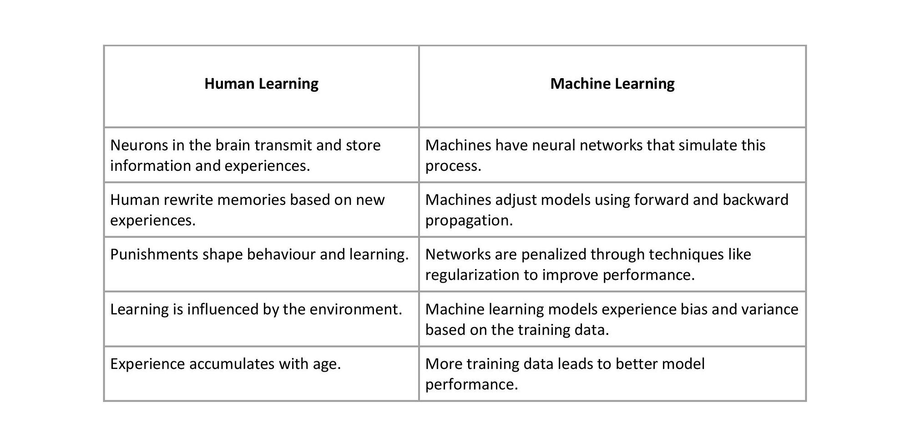
Explanation (For Textbook Use)
Human Learning Process
- Experience
- Memory recall
- Pattern recognition
- Decision making
Machine Learning Process
- Data collection
- Model training
- Pattern extraction
- Prediction / decision
You may caption this as:
Figure 2: Comparison of Human Learning and Machine Learning

Answer Key (For Chapter-End Exercises)
Conceptual Questions
1. Difference between Machine Learning and Rule-Based Programming
Traditional programming uses explicitly written rules. Machine learning systems learn patterns from data and generate predictions without manually coded rules for every scenario.

2. Relationship between AI, ML, and DL
Artificial Intelligence is the broader field.
Machine Learning is a subset of AI focused on data-driven learning.
Deep Learning is a subset of ML that uses neural networks with multiple layers.

3. Human vs Machine Learning
Humans learn from experience, recall past events, derive rules, and apply them to new situations. Machines analyze data, identify statistical patterns, train models, and use them to make predictions.

4. Definitions
- Model: Mathematical representation learned from data.
- Algorithm: Procedure used to train a model.
- Feature: Input variable used for prediction.
- Dataset: Collection of training and testing data.
- Hyperparameter: Predefined setting controlling model training.

5. Overfitting vs Underfitting
- Overfitting: Model memorizes training data but fails on new data.
- Underfitting: Model is too simple to capture underlying patterns.

Analytical Exercises
6. Learning Types
- Email spam detection → Supervised learning
- Customer segmentation → Unsupervised learning
- Self-driving car navigation → Reinforcement learning
- Product recommendation → Supervised or Unsupervised (depending on implementation)

7. Weather Prediction Example
- Features: Temperature, humidity, pressure, wind speed
- Label: Rain / No rain (classification) or temperature value (regression)

8. Training vs Test Performance Issue
- Problem: Overfitting
- Solutions:
  - Use more data
  - Apply regularization
  - Reduce model complexity
  - Use cross-validation

Reflection Exercise (Sample Answer)
Examples:
- Recommendation systems (Netflix, Spotify)
- Face recognition on smartphones
- Navigation apps predicting travel time
Each uses historical data to predict user behavior or system outcomes.

